User Guide

OpenAKC
Version 1.0 ⭓ 01 October 2020



OpenAKC © 2019-2020 ⭓ A. James Lewis ⭓ https://github.com/netlore/OpenAKC

Table of Contents
1 Introduction 3
1.1 Purpose 3
1.2 Scope 3
1.3 System Components 3
2. Installation & Configuration 4
2.1 Installing via OS repo. 4
2.1.1 Ubuntu 4
2.1.2 Debian 4
2.1.3 Redhat/Centos/Fedora 5
2.1.3.1 Older systems using YUM 5
2.1.3.2 Newer systems using DNF 5
Functions 5
Keystroke logging. 5
Examples 6
Appendices 13
1. Command Reference & Examples 13
Command “openakc-plugin” 13
Command “openakc” 15
Users 15
Admins 15
2. API Reference & Examples. 17
Stage 1 Options. 17
Stage 2 Options. 17

WARNING: This is a STUB/Incomplete Document… it contains notes, and examples which will eventually make up the OpenAKC Administrator Guide.

1 Introduction

1.1 Purpose
OpenAKC is in essence an SSH public key manager for Linux, implemented via a Client/Server API so that all public keys are held centrally. Additionally it adds advanced features such as session recording and powerful controls over how/when the keys are used, including the ability to restrict the root user after login.
Functionality including, but not limited to:-
* Centrally manage “static trust”, entirely replacing (and extending) the “authorized_keys”
functionality.
* Allow users to register personal ssh key pairs, and then be granted access based on directory
information such as AD, LDAP or even local Unix accounts, without requiring directory
access on each host in the environment (Eg. using bastion/jump hosts).
* Do session recording without requiring a “proxy” or “man-in-the-middle” to access the
session data.
* Extend the traditional restrictions which are applied to keys, permitting time/day/date based
restrictions etc.
* Manipulate Linux capabilities to restrict functions available to the “root” even after they log
in, or to restrict functions gained by using “sudo”.
* All security configuration performed in a central security server (or cluster of servers) via an
API, no access to the managed hosts is required by OpenAKC admins after the client is
installed.

1.2 Scope
This document describes the operation of OpenAKC including installation, configuration, operation and troubleshooting. It also touches on some details of the low level operation of the system, as well as recommended OpenSSH configuration to make the most of OpenAKC features.

1.3 System Components
The system consists of 3 packages, containing the client, server and API tools components.

“openakc-server” – this is the backend security server which implements the API
“openakc-tools” – this is the API tool, used by to interface with the system.
“openakc” – this is the client package installed on the systems to ba managed by OpenAKC.

2. Installation & Configuration
Depending on your environment, you may wish to install/update directly from the main repo, or download the packages for use either in a standalone environment, or in a private or corporate repository so that new versions can be tested.
Details below are by way of example, you may need to look to see what repo’s are available:-
https://github.com/netlore/OpenAKC/tree/gh-pages/repos

2.1 Installing via OS repo.
The use of “sudo”, or the root account is assumed where necessary.

2.1.1 Ubuntu/Debian
Download and add the repository key:
wget -O - https://raw.githubusercontent.com/netlore/OpenAKC/master/resources/openakc.key | apt-key add -

Add the repository:
echo "deb https://netlore.github.io/OpenAKC/repos/ubuntu/20.04 ./" > /etc/apt/sources.list.d/openakc.list

Update packages:
apt update
Install packages, depending on the requirements, using “apt install <packagename>”

2.1.2 Redhat/Centos/Fedora

2.1.2.1 Older systems using YUM
Add the repository:
wget -O - https://netlore.github.io/OpenAKC/repos/centos/7/openakc.repo > etc/yum.repos.d/openakc.repo

Install packages, depending on the requirements, using “yum install <packagename>”

2.1.2.2 Newer systems using DNF
Add the repository:
dnf config-manager --add-repo https://netlore.github.io/OpenAKC/repos/centos/8/openakc.repo

Install packages, depending on the requirements, using “dnf install <packagename>”

Functions

Keystroke logging.
Keystroke logging can be a powerful tool for security, and for understanding what went wrong when an issue occurs.

Each session opened via OpenAKC will use the same API it used to authenticate via the security server, to log some details of the connection, and assuming session recording is not disabled, it will send a record of what was displayed on the terminal, including the users actions.

This session recording is very granular (you can break down recordings by host, or by user… even tie a recording to a specific session, or PTY), and can record sessions that do not come via a specific bastion/jump host, as they are recorded at the destination and streamed back to the OpenAKC server. However, be aware however that the recordings are not 100% real time, as there is some local buffering for encryption and network reasons, otherwise the users session performance would be impacted. We therefore recommend that in high security environments, or where there may be a legal requirement to retain session recordings ,that you always use “defense in depth”, consider channelling all ssh connections via a bastion/jump host, or other choke point where session recording can also take place. The tools will then complement each other.

If you are using RedHat, for example, you could use SSSD to provide access to AD/LDAP on the bastion/jump host and security server (which OpenAKC will need), and then use tlog to record users sessions on the baston/jump host [1]. These will be much less granular, ultimately more difficult to use, since a single session on the jump host may encompass many connections to different machines and indeed may not always record what you need if there is trust between hosts inside the environment, but it is possible you may catch something which OpenAKC does not. For example, if a user does something which causes an immediate kernel panic, then some part of the session log may never be flushed from the buffers. Equally, some failure on the bastion or jump host (or a user who is able to access without going via the choke point) might cause it to miss events, but in a “separated” configuration where OpenAKC is running on dedicated servers, it will continue recording.

[1] https://access.redhat.com/documentation/en-us/red_hat_enterprise_linux/8/html-single/recording_sessions/index

Examples

Setting up a demo/test environment on Debian/Ubuntu using the script provided to automate configuration.

The script located in OpenAKC/contrib/debian-lxc-build+demo.sh will configure a basic environment for testing and/or demonstration purposes.

Eg:-
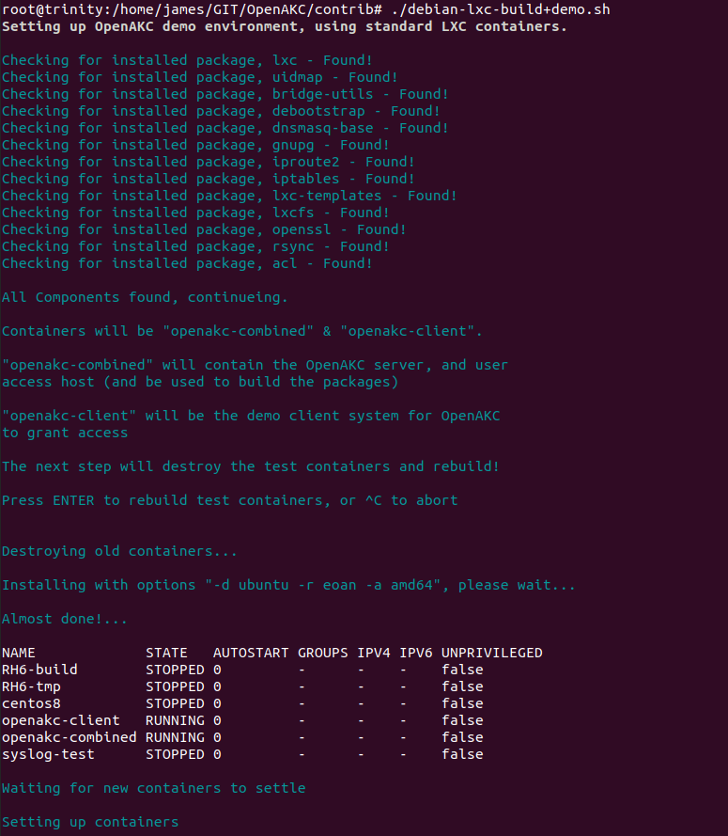
A lot of output is generated at this point as the containers are set up, and packages compiled, so it is not included here.

After the containers are built, packages compiled and installed the user is asked to enter pre-defined pass phrases into the OpenAKC registration tool, before the example role definition from the contrib folder is applied to a target application user on the demo client machine.

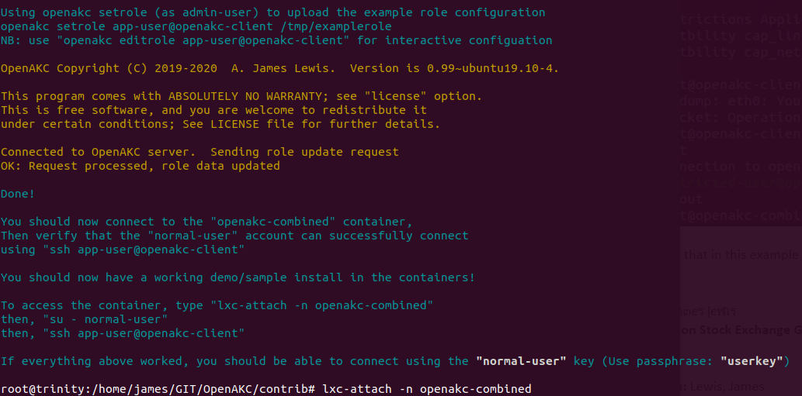
For this example, an additional user is added to demonstrate restrictions which could be applied to the root user, this user creates an ssh key pair for that user, registers with the OpenAKC server then returns to the admin-user account to create a role configuration for the demo.

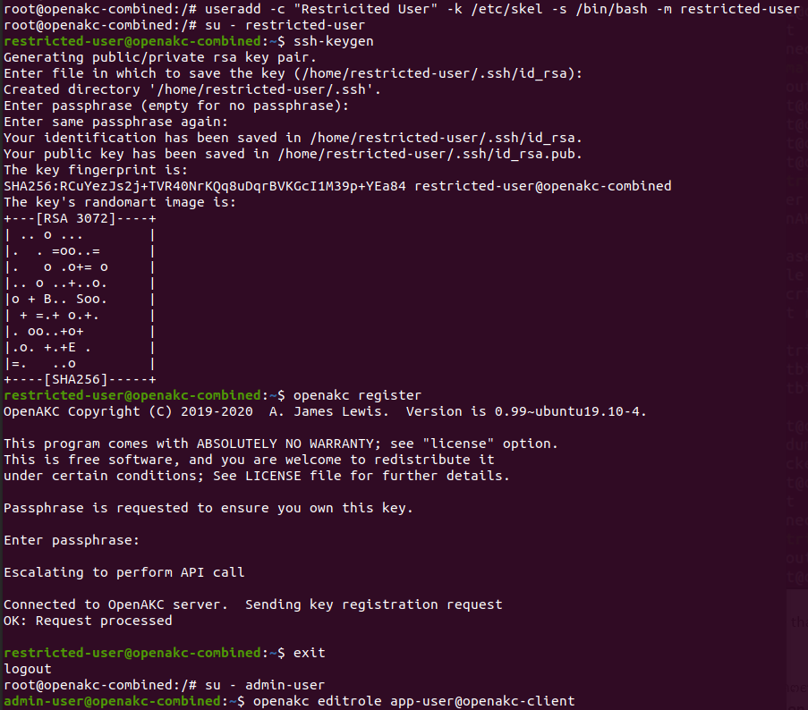

Creating the role configuration was done using “editrole” which spawns an editor (Based on the EDITOR environment variable), as shown, with the role definitions applied for the demo.

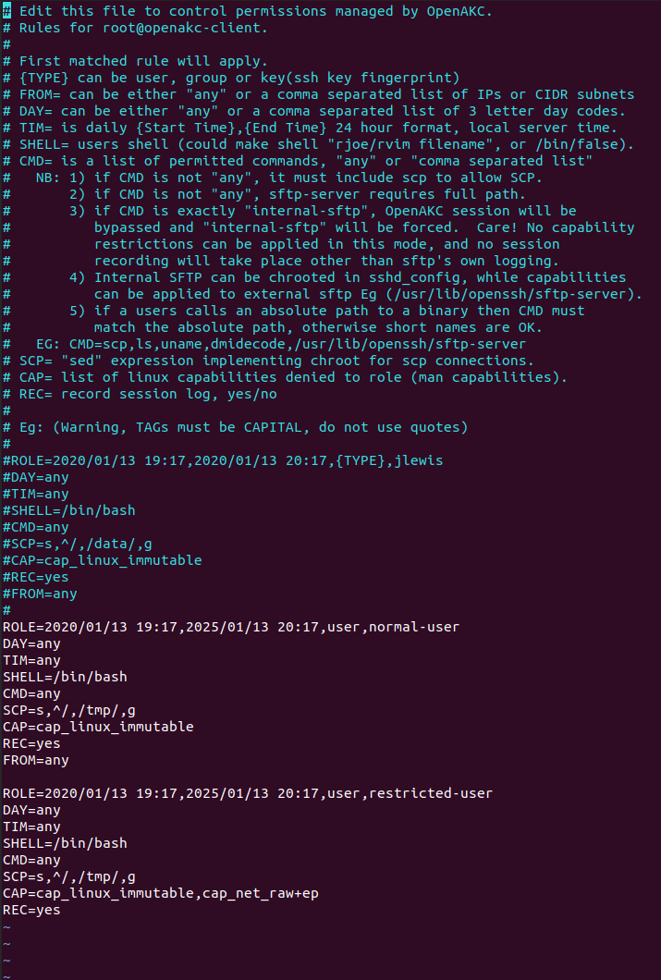
The “CAP=” field lists capabilities removed from that role, and you will note that the “restricted user” has an extra capability denied.

Now we log in to each of “normal-user” and then “restricted-user”, useing the roles thus configured to access the “root” account on the target, and show that this role definition blocks access to raw network, even for the “root” account.

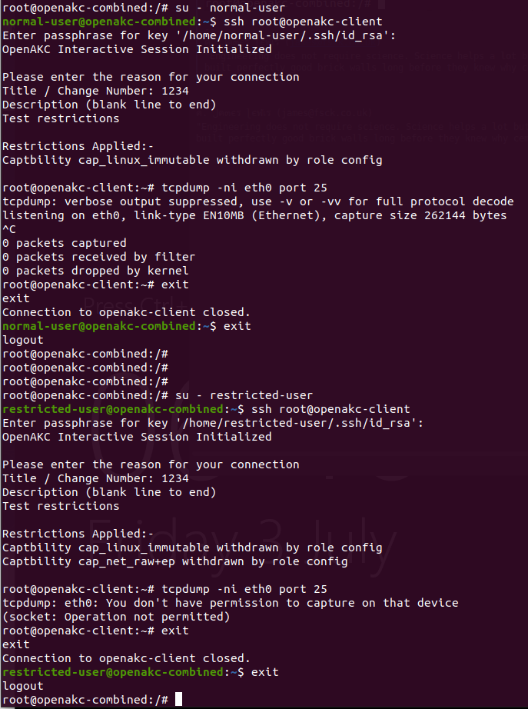

Session logs for the restricted user record the event:-

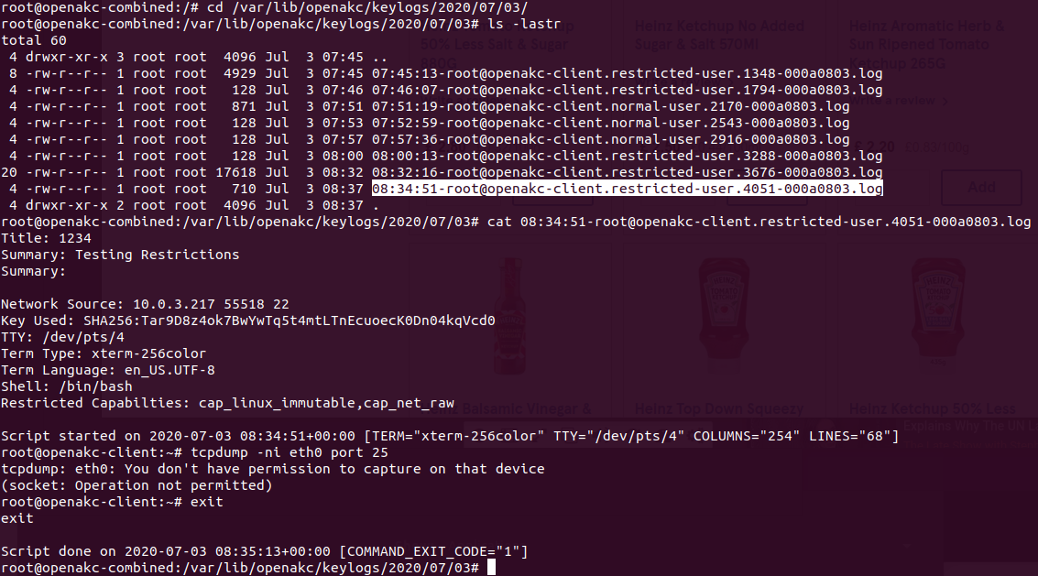

Another example of useful restrictions which could be applied using OpenAKC’s capability function would be protecting sensitive user files from the root user. You may want to have a 1st line support group who do not have full access to the system, and in this example, you can see the power of the tool, as it blocks “root” from accessing a users files, by blocking root’s ability to override file permissions… as well as it’s ability to change UID/GID via tools such as “su”.

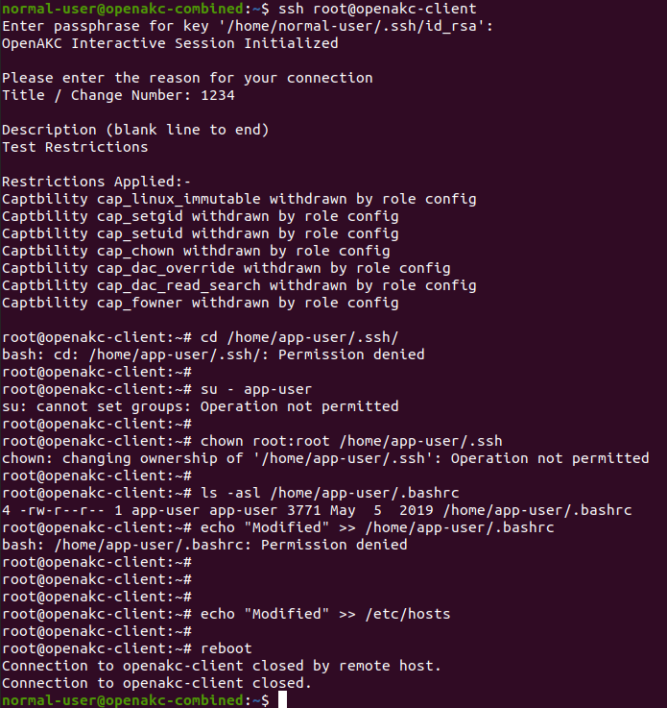
Of course, you may want to further protect the user data, by blocking access to raw disk IO, but remember, that these restrictions will eventually impact normal operation. For example, a “root” user blocked from accessing user files can create entries in /etc/passwd, /etc/shadow etc…. So could create a new user, but could not then create that users home folder. Always test new restrictions to understand where they may not be suitable.

In some other examples, session logs are able to show both non-interactive commands, and scp file transfers, as in this example, where we can see that the user executed a remote (non-interactive) command “uname -a”, and how this is recorded in the session log.

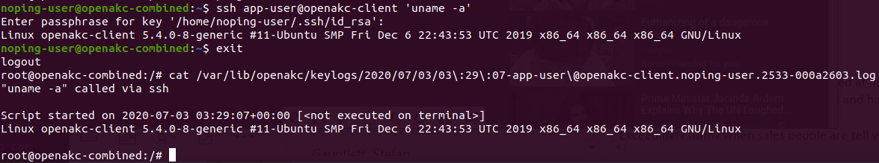

As well as SCP transfers. Note how the target is changed from /myfile to /tmp/myfile by the search/replace “sed” script in the role configuration.

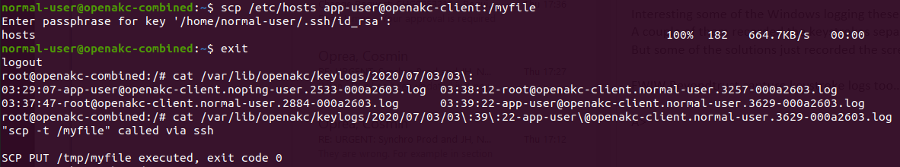

And into the local log on the client machine.

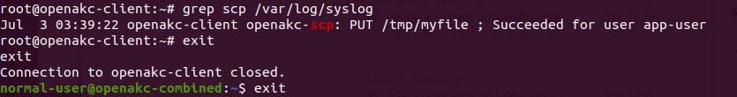

Appendices

1. Command Reference & Examples

Command “openakc-plugin”

The tool “openakc-plugin” is primarily the interface between the ssh daemon,on the client machine and the OpenAKC backend server via the API. It does however have a couple of additional functions which are are useful for debugging issues.

1. When used as a plugin, it is called in the “sshd_config” as follows (note that the installation process will update the ssh configuration so you should not need to do this manually):-
AuthorizedKeysCommand /usr/sbin/openakc-plugin %u %h %f
AuthorizedKeysCommandUser openakc

The parameters passed to the plugin include the local user and home folder of the local user for which the incoming connection wishes to be authenticated, as well as the key fingerprint of the key being used as a token. Also, notice that the client runs as an unprivileged user.

2. When running as a normal user (not root), the only other possible use of this tool is to test connectivity to the server:-

$ openakc-plugin ping

The server response “OK: Pong!” will be seen if connection is working OK.

3. When running as root there is one additional option available, this is to reset the server public keys stored on the client. This might be required if the servers identity changes. In this scenario, the client will no-longer communicate with the server until the keys are reset. This is similar to the way SSH itself will warn before connecting to a server who’s host keys have changed:-

$ openakc-plugin resetkeys

Command “openakc”

The tool “openakc” is the tool used by both users, and admins to interact with the API from the command line.

Users
OpenAKC is largely intended to be transparent to the user, at the point of use, so with the exception of restrictions imposed by the role rules (or the login reason “quiz”), the only real reason for a user to interact with AKC is to register their public key.

$ openakc register

This verifies the ownership of the public key and identity of the user, then records this information with the backend server via the API. Once recorded in this way the users public key will be made available on client machines, wherever they wish to log in, so long as the role rules governing access to that system permit them to log in.
Eg. If a new web developer “fred” joins, assuming his user account in AD (or LDAP etc.) is created as a member of the group “webadmins”, then provided there is a rule permitting members of the “webadmins” group to login in via ssh to “apache@webserver”, then “fred” only needs to create and register a suitable ssh key pair (pass phrases are mandatory), and he will instantly be able to log in to that account. There is no delay while keys are distributed, since keys are not distributed but are accessed on demand by the client as part of the authentication process.

Admins
Security administrators have two functions they can perform via the “openakc” tool.

1. Defining role rules for access to given clients, this can be done either via an editor (defined by the EDITOR environment variable).
$ openakc editrole username@hostname

Alternatively, they can download the existing roles, or upload a pre-defined set of rules.

$ openakc getrole username@hostname filename
or
$ openakc setrole username@hostname filename

The “getrole” command will overwrite file defined by “filename” with the current rules for the specified account, while the “setrole” command will upload the content of “filename” to replace the existing rules.

2. Managing static trust (equivalent to authorized_keys).
Public keys can be uploaded to the system using the “submit” command (pass phases are not enforced for this mode, but obviously recommended where possible). The openakc tool will provide a serial number when a key is submitted.

$ openakc submit filename “Comment Text”
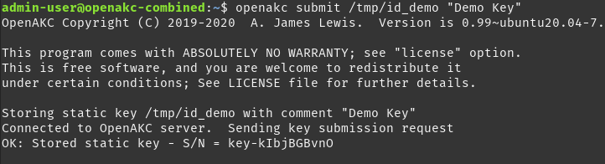
Existing public keys can be updated without changing the serial number using the “update” command. The openakc tool will overwrite the key with the specified serial number, which is useful, because rules can refer to keys by serial number, thus allowing keys to be replaced/rotated without updating all the rules which might refer to them.

$ openakc update key-serial filename “Comment Text”

As a subset of the update feature, a key can be removed from the server as follows.
$ openakc update {key-serial|username} DELETE

Note that the delete feature can also be used for user keys, perhaps when a member of staff leaves and there account is removed. Obviously deleting a users key would be a housekeeping function, as their key would not be useful after their account was deleted in whatever directory was used, but for static trust relationships it would definitely be easier to delete a key than search all the rules to see if it is referenced.

2. API Reference & Examples.

The API has 2 stages. Stage one is unencrypted, and allows the client to establish the connection, and negotiate the encryption, while stage 2 is where the business of of exchanging credentials and performing authentication happens.

Stage 1 Options.

help
ping
getproto
setproto
quit

Stage 2 Options.

Note that for debugging purposes, stage 2 commands can be sent unencrypted, or sent with encryption using the “message” command.

help
pubkey
sessioncode
challenge
handshake
setrole
getrole
listrole
registerkey
submit
update
sessiondata
message
audit
auth
ping
logturn
quit

